**Project Planning Phase**

**Project Planning Template (Product Backlog, Sprint Planning, Stories, Story points)**

|  |  |
| --- | --- |
| Date | 18 April 2025 |
| Team ID | SWTID1743603827 |
| Project Name | Book-Store |
| Maximum Marks | 5 Marks |

**Product Backlog, Sprint Schedule, and Estimation (4 Marks)**

|  |  |  |  |  |  |  |
| --- | --- | --- | --- | --- | --- | --- |
| **Sprint** | **Functional Requirement (Epic)** | **User Story**  **Number** | **User Story / Task** | **Story Points** | **Priority** | **Team**  **Members** |
| Sprint-1 | Registration | USN-1 | As a user, I can register using email and password with confirmation. | 2 | High | Shardul |
| Sprint-1 | Login | USN-2 | As a user, I can log in with email & password. | 1 | High | Shardul |
| Sprint-2 | Dashboard | USN-3 | As a user, I can see a dashboard after login. | 2 | Medium | Yashasvi |
| Sprint-2 | Product Listing | USN-4 | As a user, I can browse the product list. | 3 | High | Shreya |
| Sprint-2 | Cart | USN-5 | As a user, I can add products to the cart. | 3 | High | Shardul |
| Sprint-3 | Checkout | USN-6 | As a user, I can proceed to checkout. | 2 | High | Shreya |
| Sprint-4 | Admin Panel | USN-7 | As an admin, I can manage users and orders. | 5 | High | Nishan |
| Sprint-4 | Admin Panel | USN-8 | As an admin, I can upload and manage products. | 4 | High | Nishan |

**Project Tracker, Velocity & Burndown Chart: (4 Marks)**

|  |  |  |  |  |  |  |
| --- | --- | --- | --- | --- | --- | --- |
| **Sprint** | **Total Story Points** | **Duration** | **Sprint Start Date** | **Sprint End Date (Planned)** | **Story Points Completed (as on Planned End Date)** | **Sprint Release Date (Actual)** |
| Sprint-1 | 3 | 5 Days | 25 March 2025 | 30 March 2025 | 3 | 30 March 2025 |
| Sprint-2 | 8 | 6 Days | 31 March 2025 | 5 April 2025 | 8 | 5 April 2025 |
| Sprint-3 | 2 | 6 Days | 6 April 2025 | 11 April 2025 | 2 | 11 April 2025 |
| Sprint-4 | 9 | 2 Days | 12 April 2025 | 14 April 2025 | 9 | 14 April 2025 |

**Velocity:** Let’s calculate the team’s average velocity (AV) per iteration unit (story points per day)

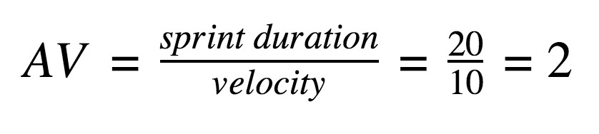

Total Story Points = 3 + 8 + 2 + 9 = 22

Total Duration = 5 + 5 + 5 + 6 = 21 days AV = 22/21≈1.05 story points per day.

**Burndown Chart:**

A burn down chart is a graphical representation of work left to do versus time. It is often used in agile [software development](https://www.visual-paradigm.com/scrum/what-is-agile-software-development/) methodologies such as [Scrum.](https://www.visual-paradigm.com/scrum/scrum-in-3-minutes/) However, burn down charts can be applied to any project containing measurable progress over time.

